- Copyright for test papers and marking guides remains with West Australian Test Papers.
- The papers may only be reproduced within the purchasing school according to the advertised conditions of sale.
- Test papers must be withdrawn after use and stored securely in the school until Friday Dec 1, 2017

HUMAN BIOLOGY

Unit 1 and 2

2016

Name: _______________________________________________________

Teacher: ___________________________________________________

Time allowed for this paper

Reading time before commencing work: ten minutes
Working time for the paper: three hours

Materials required/recommended for this paper
To be provided by the supervisor:
This Question/Answer Booklet
Multiple Choice Answer Sheet

To be provided by the candidate:
Standard items: pens (blue/black preferred), pencils (including coloured), sharpener, correction fluid/tape, eraser, ruler, highlighters

Special items: non-programmable calculators approved for use in this examination.

Important note to candidates
No other items may be taken into the examination room. It is your responsibility to ensure that you do not have any unauthorised material. If you have any unauthorised material with you, hand it to the supervisor before reading any further.

Structure of this paper

Section | Number of questions available | Number of questions to be attempted | Suggested working time (minutes) | Marks available | Percentage of examination
Section One:  Multiple-choice | 30 | All | 40 | 30 | 30
Section Two:  Short answers | 8 | All | 90 | 103 | 50
Section Three:  Extended answers | 3 | 2 | 50 | 40 | 20
 |  |  |  | Total | 100

Instructions to candidates

1. The rules for the conduct of the Western Australian Certificate of Education ATAR course examinations are detailed in the Year 12 Information Handbook 2017. Sitting this examination implies that you agree to abide by these rules.

2. Answer the questions according to the following instructions.

Section One: Answer all questions on the separate Multiple-choice answer sheet provided. For each question, shade the box to indicate your answer. Use only a blue or black pen to shade the boxes. If you make a mistake, place a cross through that square, then shade your new answer. Do not erase or use correction fluid/tape. Marks will not be deducted for incorrect answers. No marks will be given if more than one answer is completed for any question.

Section Two: Write your answers in this Question/Answer booklet. Wherever possible, confine your answers to the line spaces provided.

Section Three: Consists of three questions. You must answer two questions. Identify the question you are answering.

3. You must be careful to confine your answers to the specific questions asked and to follow any instructions that are specific to a particular question.

4. Additional working space pages at the end of this Question/Answer booklet are for planning or continuing an answer. If you use these pages, indicate at the original answer, the page number it is planned/continued on and write the question number being planned/continued on the additional working space page.

Section One: Multiple-choice 30% (30 Marks)

This section has 30 questions. Answer all questions on the separate Multiple-choice Answer Sheet provided. For each question shade the box to indicate your answer. Use only a blue or black pen to shade the boxes. If you make a mistake, place a cross through that square, do not erase or use correction fluid, and shade your new answer. Marks will not be deducted for incorrect answers. No marks will be given if more than one answer is completed for any question.

Suggested working time: 40 minutes.

- A microscope with a 10x ocular lens and 4x objective lens can fit seven mitochondria of 1mm in length. What will the field of view be with a 10x objective lens?

  - 7000µm
  - 17500µm
  - 2800µm
  - 3500µm

- In a controlled experiment, a scientist is studying the effect of increasing exercise bike resistance on heart rate and stroke volume. What is the independent variable?

  - The time spent pedalling on the exercise bike
  - The resistance to pedalling
  - The type of exercise bike
  - The heart rate and stroke volume

- During cellular respiration, approximately 38% of the energy available is used to synthesise ATP. The remaining 62% is

  - stored as fat.
  - lost as heat.
  - found within the products of cellular respiration.
  - recycled for use in other reactions.

- Whilst running, the gluteus maximus and hamstrings work together to help perform a movement. What name is given to such a pair of muscles?

- Antagonistic
- Agonitic
- Origins
- Synergitic

Use the following information to answer Question 5.

A scientist placed a culture of human cells into a solution of potassium ions. At regular intervals the concentration of potassium ions in both the external solution and inside the cells were measured. The results are shown in the graph below.

External Solution

Internal Solution

- By what process did the potassium ions leave the cell after 15 minutes?

  - Exocytosis; as the potassium ions are too large to cross the cell membrane.
  - Facilitated diffusion; as potassium moves against the concentration gradient.
  - Active transport; as potassium moves against the concentration gradient.
  - Endocytosis; as the potassium ions are too large to cross the cell membrane.

- The plasma membrane is described as a ‘mosaic’. This means the membrane consists of a

  - single layer of phospholipids with embedded proteins.
  - phospholipid bilayer with embedded proteins.
  - protein bilayer with embedded phospholipids.
  - single layer of proteins with embedded phospholipids.

- A function of the circulatory system is to help maintain levels of particular substances. This can be achieved by

- transporting materials between the tissue fluid and the external environment.
- excreting wastes from the body.
- digestion and metabolism of nutrients.
- coordination of metabolic reactions.

Use the diagram below of an erythrocyte in solution to answer Question 8.

Water Molecule

Solute Molecule

- What is the tonicity of the solution and the effect it will have on the cell?

- Hypotonic; cell will swell and lyse
- Hypotonic; cell will shrivel up
- Hypertonic; cell will swell and lyse
- Hypertonic; cell will shrivel up

Use the information below to answer Question 9.

A study investigating the effects of environment and genetics on the development of asthma was undertaken. The data below shows the correlation coefficient for both of the twins having asthma.

Type of Twins | Correlation Coefficient
Identical  Male | 0.82
Identical  Female | 0.79
Non-identical  Male | 0.27
Non-identical  Female | 0.29

- Which of the following best explains what the data suggests about the causes of asthma?

  - Large genetic influence
  - Large gender influence
  - Large environmental influence
  - Small genetic influence


- The shapes below illustrate different blood vessels.

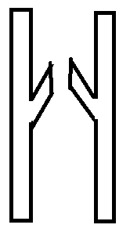


1 2 3 4

Which of the following correctly matches the shapes with the names of the blood vessels shown?

- 1 = Capillary, 2 = Artery, 3 = Artery, 4 = Vein
- 1 = Artery, 2 = Vein, 3 = Vein, 4 = Capillary
- 1 = Vein, 2 = Artery, 3 = Capillary, 4 = Capillary
- 1 = Artery, 2 = Vein, 3 = Capillary, 4 = Vein

- Police in Australia are armed with a taser. This device fires electrical impulses similar to that of action potentials into a suspect with a frequency of 15 to 20 per second.

Which of the following best explains the effect a taser has on a suspect’s muscles?

- Causes the body to release neurotransmitters causing the muscles to contract and relax rapidly
- Electricity is sent directly into the muscles causing them to contract uncontrollably
- Electric pulses match those used by neurons, which override the body’s natural signals and cause the muscles to rapidly twitch
- Hijacks the central nervous system, causing the muscles to contract and relax rapidly

- Osteoporosis often shows no signs or symptoms. Which of the following would be an indicator to undergo testing for this disease?

  - Pain in your legs and arms
  - Feeling weak and tired
  - Stiff joints with minimal movement
  - Loss of 3cm or more in height

- The majority of carbon dioxide is transported in the blood by

  - carbaminohaemoglobin.
  - bicarbonate ions.
  - oxyhaemoglobin.
  - deoxyhaemoglobin.

- Reabsorption of ions, such as chlorine, in the nephron does not occur in the

  - proximal convoluted tubule.
  - renal corpuscle.
  - distal convoluted tubule.
  - collecting duct.

- The cartilage in the nose that provides form and support is best described as being

  - hyaline cartilage.
  - fibrocartilage.
  - elastic cartilage.
  - smooth cartilage.

Use the diagram of the ballerina below to answer Question 16.



- The movement of the hip joint allowing the ballerina to lift her leg is best described as

  - flexion.
  - abduction.
  - adduction.
  - extension.

- Cancer cells, although not under normal cell replication control, are not attacked by the body’s immune system. The best reason to explain why the body treats cancer cells as one of its own is that cancer cells contain the same

- receptor proteins on the cell membrane as non-cancer cells.
- receptor proteins embedded within the cell membranes as non-cancer cells.
- identity markers embedded within the cell membranes as non-cancer cells.
- identity markers found on the cell membrane as non-cancer cells.

- A forensic officer collected biological evidence that was lacking nucleated cells from a crime scene. What biological technique may the investigator undertake to help detectives find the perpetrator?

- DNA analysis
- Marker analysis
- PCR analysis
- mtDNA analysis

- The ABO blood system is an example of which type of genetic inheritance?

- Multiple Allele Inheritance
- Sex-linked Inheritance
- Simple Inheritance
- Polygenic Inheritance

Use the information below to answer Question 20.

Between 1944 and 1954 over 17,000 cases of Polio were notified in Australia, with 1000 deaths. One of the symptoms of polio is the inability to breathe easily due to the effects on the muscles of the respiratory system. This resulted in patients having to lie down in a machine called an iron lung for an extended period.

- Which of the following is the best explanation of why patients in an iron lung are at risk of blood clots?

  - Low levels of the mineral iron cause the thickening of blood which leads to clot formation
  - Prolonged lack of activity causing the pooling of blood in veins leading to clot formation
  - Use of the iron lung causes pulmonary obstructions which can dislodge and travel through the circulatory system leading to clot formation
  - The iron lung increases a patient’s blood pressure which can damage the circulatory system and lead to clot formation

- The following components of the cell are involved in protein synthesis and secretion.

I Ribosome
II Cytoplasm
III Golgi Body
IV Endoplasmic reticulum

Which of the following sequences correctly identifies the path an amino acid molecule would take as a protein is formed and transported from the cell?

- I, II, III, IV
- II, I, IV, III
- I, III, II, IV
- IV, I, III, II

- The use of the rhythm method as an effective use of contraception relies on

- using a mix of herbal and vitamin supplements.
- the use of steroid hormones.
- having intercourse according to the couple’s natural desires.
- monitoring a woman’s fertility and menstrual cycle.

- The presence of dimples is a dominant characteristic in humans. A child’s mother has no dimples and its father is heterozygous for dimples.

What is the probability that this child will have dimples?

- 25%
- 50%
- 75%
- 100%

Use the diagram below to answer Question 24 – 26.

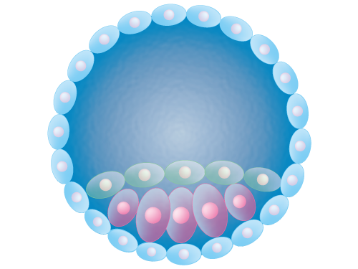
X

- Which germinal stage of human embryogenesis does the diagram above represent?

- Implantation
- Fertilisation
- Cleavage
- Blastulation

- During this stage, which structure releases hormones that maintain the endometrium ready for implantation?

- Placenta
- Corpus luteum
- Ovary
- Zygote

- Which type of stem cells are those identified by the letter X?

- Totipotent
- Pluripotent
- Multipotent
- Adult Stem Cells

- At which stage of meiosis does genetic recombination, or crossing over, occur?

  - Prophase I
  - Prophase II
  - Metaphase I
  - Metaphase II

- Duchenne muscular dystrophy often results in the loss of muscle mass and functional capacity. Areas of the affected muscle fibres are replaced with fat deposits and can result in the muscle appearing larger.

When viewing a sample of an affected muscle under a microscope, the sample would show

  - increased numbers of skeletal muscle fibres.
  - hypertrophy; enlarged diameters of muscle fibres.
  - multiple peripheral cells undertaking mitosis.
  - increased amount of connective tissue and muscle cells of different sizes.

Use the pedigree chart below to answer Question 29.

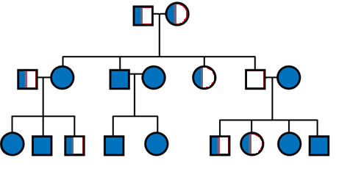

- The type of inheritance displayed in the pedigree chart is best described as

  - autosomal dominant.
  - autosomal recessive.
  - co-dominant.
  - sex-linked.

- A bacterial culture contains methyl-labelled thymine (T^). The culture is transferred to a solution containing unlabelled thymine, and after one round of replication the DNA is analysed. Which of the following could be representative of the analysed DNA?

  - T^ T A A C G
A A T^ T G C
  - T^T^A A C G
A A T T G C
  - T T A A C G
A A T T G C
  - T^T^A A C G
A A T^ T^ G C

Section Two: Short answer 50% (103 Marks)

This section has eight (8) questions. Answer all questions. Write your answers in the spaces provided.

Spare pages are included at the end of this booklet. They can be used for planning your responses and/or as additional space if required to continue an answer.
  - Planning: If you use the spare pages for planning, indicate this clearly at the top of the page.
  - Continuing an answer: If you need to use the space to continue an answer, indicate in the original answer space where the answer is continued, i.e. give the page number. Fill in the number of the question(s) that you are continuing to answer at the top of the page.

Suggested working time: 90 minutes.

Question 31 (15 marks)

Huntington’s disease (HD) is an inherited neurodegenerative disorder due to a defective gene located on chromosome 4. Parents-to-be with a history of HD in their families often visit a genetic counsellor to discuss the possibilities and implications of the disease.

- It is found that a husband is heterozygous for HD whilst the wife is homozygous recessive.

In the space below, predict the possible genotypes and phenotypes of their future children.
(5 marks)

- Construct a pedigree diagram the genetic counsellor may have drawn to explain the couple’s chances of inheritance.

Your pedigree should include:
- two generations of the family
- the wife’s sister and brother whom are all unaffected
- the husband’s older brother who died from HD symptoms
- the prediction of two future children, one of each gender
(7 marks)

- Describe a suitable prenatal genetic test that could be used to determine if an unborn child has HD, and state one risk associated with the test.
(3 marks)
___________________________________________________________________
___________________________________________________________________
___________________________________________________________________
___________________________________________________________________

Question 32 (8 marks)

A study that began in 2008 aimed to test the safety and effectiveness of a contraception injection on sperm count in 320 healthy men. Conducted at health centres around the world, the men were required to be between 18 – 45 years old and in a monogamous relationship of at least 1 year with a female partner. Each participant underwent testing to ensure they had a normal sperm count of at least 15 million/mL prior to commencement. The contraception shot was given intramuscularly every 8 weeks and consisted of 1200 milligrams of synthetic forms of hormones.

- Identify the following variables:

- Independent variable (1 mark)

____________________________________

- Dependent variable (1 mark)

____________________________________

Variables that may affect the outcome of an investigation must be kept constant to ensure a fair test.

- State two variables that were controlled in the study.
(2 marks)
______________________________________________________________________________________________________________________________________

- Describe one change that would improve the validity of the data collected in the study.
(2 marks)
___________________________________________________________________
______________________________________________________________________________________________________________________________________
___________________________________________________________________

Human Research Ethics Committees play a central role in the ethical oversight of human based research.

- Describe one principle that this study would have needed to satisfy in order to be ethically sound.
(2 marks)
___________________________________________________________________
___________________________________________________________________
___________________________________________________________________
___________________________________________________________________

Question 33 (12 marks)

The data below shows the percentage of blood that flows to specific organs at rest and during exercise.

 | Blood Flow (%)
Organ | Exercise | Rest
Skeletal Muscle | 70 | 15
Skin | 15 | 5
Stomach | 2 | 25

- Plot the data comparing the two sets of data for the body organs listed in the table above.

A spare grid can be found on page 37.
(5 marks)

- Explain how the structure of arteries allow for these alterations in blood flow.
(3 marks)

_______________________________________________________________________________________________________________________________________________________________________________________________________________________________________________________________________________________________________________________________________________

The increase in blood flow to skeletal muscles during exercise is related to the production of energy. Aerobic exercises are those at a moderate intensity that increase the heart rate and deliver more blood to the muscles, whereas anaerobic exercises are defined as those that prevent you breathing normally.

- State two disadvantages and two advantages of anaerobic exercises.

(4 marks)
___________________________________________________________________
___________________________________________________________________
___________________________________________________________________
___________________________________________________________________
___________________________________________________________________
___________________________________________________________________

Question 34 (12 marks)

- State the three germ layers formed in the embryo after implantation and for each germ layer, identify one structure in the adult body that develops from it.
(6 marks)

Germ Layer | Structure that forms from it

- Placental abruption is a condition where the placenta begins to come away from the wall of the womb. Describe one effect this may have on the growing foetus.
(2 marks)
___________________________________________________________________
_________________________________________________________________________________________________________________________________________________________________________________________________________

- Patent foramen ovale (PFO) is the name given to the incomplete closure of the hole between the atria in the heart of newborns. Discuss the importance of the foramen ovale in foetuses and the possible implications of PFO.
(4 marks)
___________________________________________________________________
_________________________________________________________________________________________________________________________________________________________________________________________________________
______________________________________________________________________________________________________________________________________

Question 35 (18 marks)

The diagram below represents the urinary system of the human body.
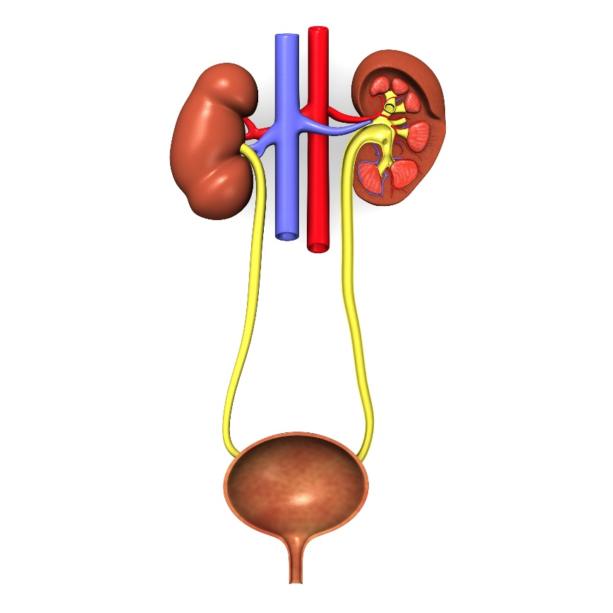
Z
Y
- Identify the following labelled structures and state a function for each.
(4 marks)
Y ______________________________________________

______________________________________________

Z ______________________________________________

______________________________________________

- Describe the processes that occur during excretion in the kidneys.
(6 marks)
___________________________________________________________________
_________________________________________________________________________________________________________________________________________________________________________________________________________
_________________________________________________________________________________________________________________________________________________________________________________________________________
- Explain how the structure of the nephron relates to its function to excrete wastes.
(4 marks)
___________________________________________________________________
_________________________________________________________________________________________________________________________________________________________________________________________________________
______________________________________________________________________________________________________________________________________

Urea is a metabolic waste that is excreted primarily from the kidneys.

- Describe the formation of urea in the body and state an organ besides the kidneys that excretes this metabolic waste.
(4 marks)
___________________________________________________________________
___________________________________________________________________
___________________________________________________________________
___________________________________________________________________
___________________________________________________________________
___________________________________________________________________
___________________________________________________________________
___________________________________________________________________
___________________________________________________________________

Question 36 (14 marks)

When cells begin to grow and divide at a faster rate than those around them they produce masses known as tumours. If cancerous, these tumours can be treated by radiation therapy that causes double stranded breaks in nucleic acids during the M phase of the cell cycle.

- Explain how radiation therapy causes cancerous cells to die if the cells attempt to divide.
(3 marks)
___________________________________________________________________
___________________________________________________________________
___________________________________________________________________
___________________________________________________________________
___________________________________________________________________
___________________________________________________________________

The diagram below shows the structure of a tRNA molecule.

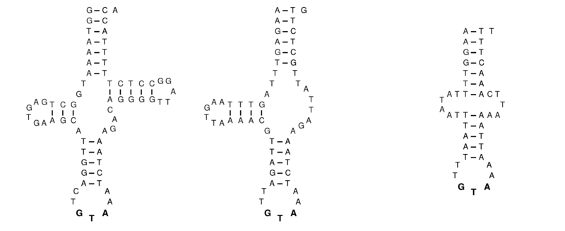
- Explain the structure of the tRNA molecule that gives it this specific shape.
(3 marks)
___________________________________________________________________
___________________________________________________________________
___________________________________________________________________
___________________________________________________________________
___________________________________________________________________
Deoxyribonucleic acid (DNA) is a self-replicating molecule that acts as a carrier for genetic information, storing the sequences to produce particular proteins.

- Outline the process that would result in the production of a protein from a strand of mRNA.
(5 marks)
___________________________________________________________________
___________________________________________________________________
___________________________________________________________________
___________________________________________________________________
___________________________________________________________________
___________________________________________________________________
___________________________________________________________________

- Identify a specialised cell that produces proteins for transport outside the cell.
(1 mark)
___________________________________________________________________

- State one cell organelle that would be found in abundance in the cell identified in part (d) above, and give a reason why.
(2 marks)
___________________________________________________________________
___________________________________________________________________
___________________________________________________________________

Question 38 (12 marks)

The skeletal system of the human body is shown in the diagram below.

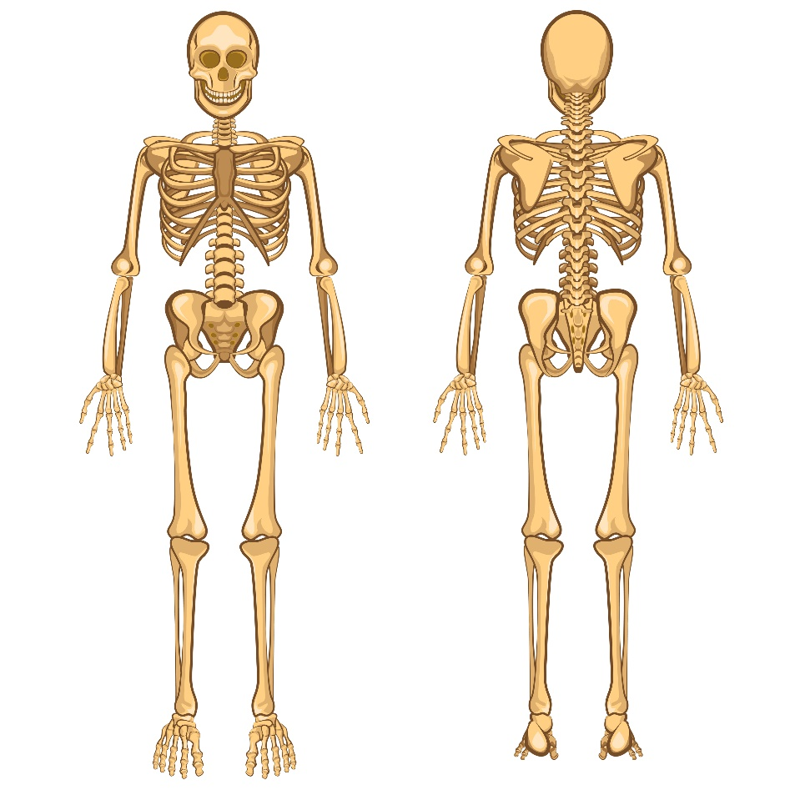
B
D
C
A
A
- Identify the letter/s that make up part of the axial skeleton.
(1 mark)
______________________________________________

- The femur is an example of a long bone. Draw a cross section diagram through a long bone and identify the compact bone, spongy bone and epiphysis.
(3 marks)

- Outline how two named features of the hip joint help prevent injury and allow for stability when moving.
(4 marks)
___________________________________________________________________
___________________________________________________________________
___________________________________________________________________
___________________________________________________________________
___________________________________________________________________

A 60-year old patient is exhibiting signs of hip pain, decreased range of motion, and a popping feeling when walking.

- State the degenerative disease most likely attributed to this patient.
(1 mark)
______________________________________________________

- Suggest a management plan the doctor may assign to help assist the patient.
(3 marks)
___________________________________________________________________
___________________________________________________________________
___________________________________________________________________
___________________________________________________________________
___________________________________________________________________
___________________________________________________________________

Section Three: Extended answer 20% (40 Marks)

This section contains three (3) questions. You must answer two (2) questions. Make sure you clearly indicate which question you are answering and write your answers in the space provided.

Spare pages are included at the end of this booklet. They can be used for planning your responses and/or as additional space if required to continue an answer.
  - Planning: If you use the spare pages for planning, indicate this clearly at the top of the page.
  - Continuing an answer: If you need to use more space to continue an answer, indicate in the original answer space where the answer is continued, i.e. give the page number. Write the number of the question(s) that you are continuing to answer at the top of the additional space page.

Responses could include clearly labelled diagrams with explanatory notes; lists of points with linking sentences; clearly labelled tables and graphs; and annotated flow diagrams with introductory notes.

Suggested working time: 50 minutes.

Question 39 (20 marks)

During the 1944-45 winter of World War II (Dutch Hunger Winter), many pregnant mothers were forced into severe malnourishment. The babies born during this time were smaller than average. As a result, the following two generations of children were also underweight.

- Describe two epigenetic mechanisms that may explain why subsequent offspring from the Dutch Hunger Winter inherited lower birthweights. In your answer, refer to what epigenetics is and a possible reason that may have caused the changes.
(10 marks)

The subjects of the study were required to have samples of their DNA taken for profiling by scientists.

- State the name and outline the process used to create DNA fingerprints.
(6 marks)

- Discuss ethical implications that should be considered when using genetic profiling.
(4 marks)

Question 40 (20 marks)

Jill is a 46-year-old woman who recently began attending ‘boxercise’ classes at her local gym. At the end of each session, she finds herself fatigued and breathing more quickly than normal.

- Explain the theory behind the physiology of muscle fibre contraction that allows Jill to move during her ‘boxercise’ session.
(7 marks)

- Outline the mechanics of breathing.
(10 marks)

- Describe the process by which oxygen molecules are transported across the cell membrane.
(3 marks)

Question 41 (20 marks)

There is an increasing occurrence of infertility in Australia, with one in six couples experiencing fertility problems. One cause of infertility is the decreased production of sperm and/or egg cells.

- Outline the sequence of DNA replication.
(5 marks)

- Compare and contrast the processes of gametogenesis in males and females.
(10 marks)

A variety of assisted reproductive technologies have helped in overcoming some infertility problems.

- Describe how in-vitro fertilisation (IVF) differs from natural fertilisation and discuss the risks involved in IVF.
(5 marks)

End of Examination

Question number: ________________
__________________________________________________________________________________________________________________________________________________
_________________________________________________________________________
_________________________________________________________________________
_________________________________________________________________________
_________________________________________________________________________
__________________________________________________________________________________________________________________________________________________
_________________________________________________________________________
_________________________________________________________________________
_________________________________________________________________________
_________________________________________________________________________
__________________________________________________________________________________________________________________________________________________
_________________________________________________________________________
_________________________________________________________________________
_________________________________________________________________________
_________________________________________________________________________
__________________________________________________________________________________________________________________________________________________
_________________________________________________________________________
_________________________________________________________________________
_________________________________________________________________________
_________________________________________________________________________
__________________________________________________________________________________________________________________________________________________
Question number: ________________
__________________________________________________________________________________________________________________________________________________
_________________________________________________________________________
_________________________________________________________________________
_________________________________________________________________________
_________________________________________________________________________
__________________________________________________________________________________________________________________________________________________
_________________________________________________________________________
_________________________________________________________________________
_________________________________________________________________________
_________________________________________________________________________
__________________________________________________________________________________________________________________________________________________
_________________________________________________________________________
_________________________________________________________________________
_________________________________________________________________________
_________________________________________________________________________
__________________________________________________________________________________________________________________________________________________
_________________________________________________________________________
_________________________________________________________________________
_________________________________________________________________________
_________________________________________________________________________
__________________________________________________________________________________________________________________________________________________
_________________________________________________________________________
Question number: ________________
__________________________________________________________________________________________________________________________________________________
_________________________________________________________________________
_________________________________________________________________________
_________________________________________________________________________
_________________________________________________________________________
__________________________________________________________________________________________________________________________________________________
_________________________________________________________________________
_________________________________________________________________________
_________________________________________________________________________
_________________________________________________________________________
__________________________________________________________________________________________________________________________________________________
_________________________________________________________________________
_________________________________________________________________________
_________________________________________________________________________
_________________________________________________________________________
__________________________________________________________________________________________________________________________________________________
_________________________________________________________________________
_________________________________________________________________________
_________________________________________________________________________
_________________________________________________________________________
__________________________________________________________________________________________________________________________________________________
_________________________________________________________________________
Question number: ________________
__________________________________________________________________________________________________________________________________________________
_________________________________________________________________________
_________________________________________________________________________
_________________________________________________________________________
_________________________________________________________________________
__________________________________________________________________________________________________________________________________________________
_________________________________________________________________________
_________________________________________________________________________
_________________________________________________________________________
_________________________________________________________________________
__________________________________________________________________________________________________________________________________________________
_________________________________________________________________________
_________________________________________________________________________
_________________________________________________________________________
_________________________________________________________________________
__________________________________________________________________________________________________________________________________________________
_________________________________________________________________________
_________________________________________________________________________
_________________________________________________________________________
_________________________________________________________________________
__________________________________________________________________________________________________________________________________________________
_________________________________________________________________________
Question number: ________________
__________________________________________________________________________________________________________________________________________________
_________________________________________________________________________
_________________________________________________________________________
_________________________________________________________________________
_________________________________________________________________________
__________________________________________________________________________________________________________________________________________________
_________________________________________________________________________
_________________________________________________________________________
_________________________________________________________________________
_________________________________________________________________________
__________________________________________________________________________________________________________________________________________________
_________________________________________________________________________
_________________________________________________________________________
_________________________________________________________________________
_________________________________________________________________________
__________________________________________________________________________________________________________________________________________________
_________________________________________________________________________
_________________________________________________________________________
_________________________________________________________________________
_________________________________________________________________________
__________________________________________________________________________________________________________________________________________________
_________________________________________________________________________
Question number: ________________
__________________________________________________________________________________________________________________________________________________
_________________________________________________________________________
_________________________________________________________________________
_________________________________________________________________________
_________________________________________________________________________
__________________________________________________________________________________________________________________________________________________
_________________________________________________________________________
_________________________________________________________________________
_________________________________________________________________________
_________________________________________________________________________
__________________________________________________________________________________________________________________________________________________
_________________________________________________________________________
_________________________________________________________________________
_________________________________________________________________________
_________________________________________________________________________
__________________________________________________________________________________________________________________________________________________
_________________________________________________________________________
_________________________________________________________________________
_________________________________________________________________________
_________________________________________________________________________
__________________________________________________________________________________________________________________________________________________
_________________________________________________________________________
Question number: ________________
__________________________________________________________________________________________________________________________________________________
_________________________________________________________________________
_________________________________________________________________________
_________________________________________________________________________
_________________________________________________________________________
__________________________________________________________________________________________________________________________________________________
_________________________________________________________________________
_________________________________________________________________________
_________________________________________________________________________
_________________________________________________________________________
__________________________________________________________________________________________________________________________________________________
_________________________________________________________________________
_________________________________________________________________________
_________________________________________________________________________
_________________________________________________________________________
__________________________________________________________________________________________________________________________________________________
_________________________________________________________________________
_________________________________________________________________________
_________________________________________________________________________
_________________________________________________________________________
__________________________________________________________________________________________________________________________________________________
_________________________________________________________________________
Additional Working
__________________________________________________________________________________________________________________________________________________
_________________________________________________________________________
_________________________________________________________________________
_________________________________________________________________________
_________________________________________________________________________
__________________________________________________________________________________________________________________________________________________
_________________________________________________________________________
_________________________________________________________________________
_________________________________________________________________________
_________________________________________________________________________
__________________________________________________________________________________________________________________________________________________
_________________________________________________________________________
_________________________________________________________________________
_________________________________________________________________________
_________________________________________________________________________
__________________________________________________________________________________________________________________________________________________
_________________________________________________________________________
_________________________________________________________________________
_________________________________________________________________________
_________________________________________________________________________
__________________________________________________________________________________________________________________________________________________
_________________________________________________________________________
Spare Grid

Acknowledgements

Question 15
AJ.iitm (2012) Ballerina Logo [Artwork] Retrieved April 10, 2017, from https://commons.wikimedia.org/wiki/File:Ballerina_logo.png?uselang=en-gb#/media/File:Ballerina_logo.png

Question 20
en:User:Wapcaplet (2006) Heart numlabels [Artwork] Retrieved April 10, 2017 from
https://commons.wikimedia.org/wiki/File:Heart_numlabels.svg?uselang=en-gb

Question 24
Database Center for Life Science (2013) Embryo [Artwork] Retrieved April 10, 2017 from
http://bit.ly/2rIGB99

Question 29
Walker, J (2006) Pedigree Chart [Artwork] Retrieved April 10, 2017 from
http://bit.ly/2qMWV9u

Question 34
3drenderings (n.d.) Urinary System [Artwork] Retrieved 27 March, 2017 from https://www.dreamstime.com/royalty-free-stock-photos-urinary-system-image10634818#res18124506

Question 36
Knarf (2012) An example of an aberrant tRNATyr [Artwork] Retrieved 24 May, 2017 from
https://commons.wikimedia.org/wiki/File%3AMt-tRNA(Tyr).png

Question 37
Brancaesova (n.d.) Human Skeleton [Artwork] Retrieved 27 March, 2017 from https://www.dreamstime.com/royalty-free-stock-images-human-skeleton-vector-illustration-body-anatomy-internal-organ-image34569329#res18124506

